

**Rainbow Worksheet Series**

*Right click the icon below,*

*Open the link,*

*Start your learning journey…*

[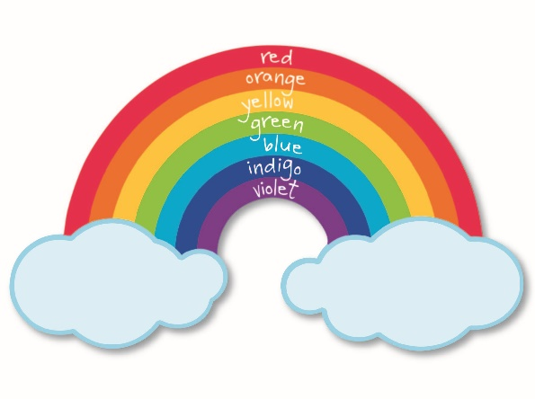](https://mybinder.org/v2/gh/kwng71/Kwng71_ScienceWorkshop/master?filepath=Overview.ipynb)